# EMMI Session #2: 16-07-2024

By Eya Lahiani

Today, we delved into the fascinating world of proteins, learning about the different levels of protein structure. We explored:

* **Primary Structure:** The sequence of amino acids in a polypeptide chain.
* **Secondary Structure:** The formation of alpha-helices and beta-sheets stabilized by hydrogen bonds.
* **Tertiary Structure:** The three-dimensional folding pattern of a protein due to side chain interactions.
* **Quaternary Structure:** The assembly of multiple polypeptide chains into a functional protein complex.

Furthermore, we familiarized ourselves with the nomenclature and the names of 20 amino acids. We also learned about ligand binding and the effects of mutations on protein function.

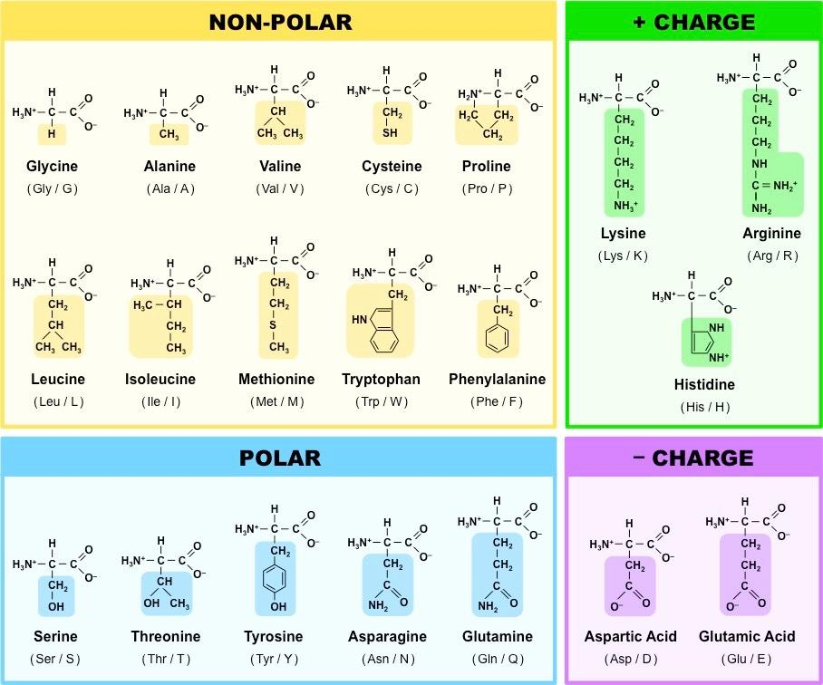

We studied the various types of non-covalent protein-ligand interactions:

* **Hydrogen Bonds:** Formed between polar groups.
* **Electrostatic Bonds:** Occurring between charged groups.
* **Hydrophobic Interactions:** Involving non-polar groups avoiding water.

=> Understanding these interactions helps us appreciate how proteins bind to their ligands based on amino acid and ligand properties.

Moreover, we learned how to access online servers and locate key information for our bioinformatics projects. This included:

* Utilizing databases like PDB for protein structures.
* Accessing NCBI for genetic and protein sequence information. (we used GenBank: <https://www.ncbi.nlm.nih.gov/genbank/>)
* Exploring tools like Basic Local Alignment Search Tool (BLAST): <https://blast.ncbi.nlm.nih.gov/Blast.cgi> for sequence alignment and comparison.

And others like:

* Basic Research: <https://www.ncbi.nlm.nih.gov/>
* Annotated Database: [Nucleic Acids Research, 2013 Jan;41(D1):D36-42](https://www.ncbi.nlm.nih.gov/pubmed/23193287)
* An [annotated sample GenBank record](https://www.ncbi.nlm.nih.gov/genbank/samplerecord/) for a Saccharomyces cerevisiae gene demonstrates many of the features of the GenBank flat file format.

# Gallery:

